Name
Professor
Date
App/ Mobile Market

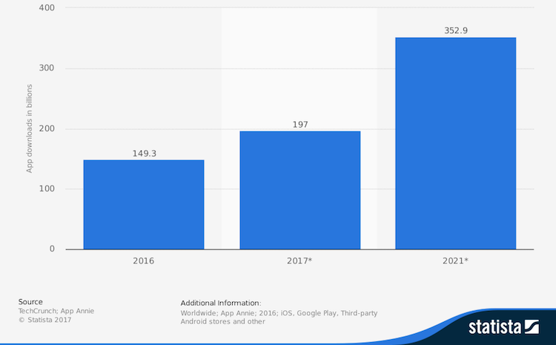

There has being a tremendous increase in the number of smartphone users in the world. The mobile market in the United States has being gaining popularity from the increase in technology in the word. The world has being embracing technology and that has led to increased mobile and app use in the world. The increase in the market has being brought about by the increased business to consumer engagement. There are businesses that are trying to cut down on their costs by reducing the number of physical locations and increasing the level of consumer awareness in the world. The business have being able to come up with business applications that will enable the consumers to transact directly with the business on the requirements and also track the processing level of the business orders made. The other cause of the increment has being caused by the increased use of business apps by banks. There has being increasing demand by customers to transact online and beware of any bank transactions that may be occurring in their personal accounts or their business transactions.
The increase in the number of smartphone users has led to the tremendous increase in the number of app users that are being sued by the consumers. The Apple app is considered the most sort after app with more than 2 million users. The Google play app has approximately more than 2.2 million users in the world. In the future, the numbers are expected to increase significantly. There was an info graphics released by Go-Globe that indicated that there is a significant growth in the use of mobile apps (Adrian pg 12). The users of the smartphones have being able to understand the role-played by the apps in assisting the businesses and customers gather information that is essential for their transactions. According to 2017 statistics, 52% of the time that is sued by people on digital media is on the mobile apps.
According to research conducted by com score, the number of mobile app users has surpassed the number of desktop users as at 2014. The increase in the number of users has being effected by the fact that the mobile apps are accommodating the desktop features and the mobile phone features. A report by Gartner predicts that there will be more than 268 billion downloads that is expected to generate income of $ 77 billion. The revenue form the app use in 2014 was $ 35 billion, $ 45 billion in 2015, and $ 58 billion in 2016. According to statistics, the people who fall in the age group that is between 18 and 24 years make use of the mobile apps more than any other age group. The next age group that makes use of the mobile apps is the group aged between 25 and 34 years. The mobile app companies are there coming up with apps that will target the age group that makes use of the mobile apps more frequently.
According to the statistics, the number of women who make use of the mobile apps is more that the number of men who make use of the app. The period that is spent on the mobile apps increased by 20% from 201 to 2015. According to the statistics, the mobile apps are used 43% for gaming, 26% for social networking, 10% for utilities, 10% for entertainment and 2 % for productivity and news. There is also a 1% usage on lifestyle and health fitness.

App categories
There are different categories for mobile apps. The categories will include the social networking apps. The use of social medial has enabled business to transact and interact online with their customers. That has increased their level of efficiency and ability to communicate with their customers in the current and future state. Some of the effective social media applications include Facebook, Twitter, and Instagram. The platforms are used by different people who express their own personal concerns and the avenue has also being used by the companies to transact with the consumers. The other mobile apps that are effective include the mobile loan apps. The different banking institutions are being able to advance their customers with loans on the platform. That minimizes the time that is used by the customers when accessing the loans. The mobile apps also ensure that the banks can cut on employee costs by making use of the mobile app platform that does not require the use of many employees to be engaged in the approval process.

CONSUMER PACKAGED GOODS

Consumer packaged goods refer to the items that are used on a routine basis by the average consumers. The goods that are found in the category include the goods that are frequently replaced compared to the periods that are extended. The basic CPGs examples include household products, tobacco, clothing, beverages, and food. The household products that are sued on a routine basis would include toiletries, detergents, and cleaning items. The different households and companies make use of this items on a daily basis. The other item is the food consumed by people. A meal a day is a requirement for the normal person in the world. People have to take different meals for them to gain energy and that makes food a CPG item. Tobacco is also a CPG. The users of tobacco are usually addicts and that means that they have to use the product on a regular basis. Clothing is another necessity, people frequently change their clothes on a routine basis, and that makes them part of the CPG items.
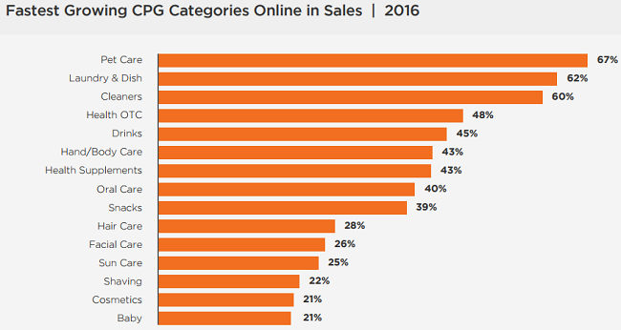

Manufacturers of CPGs
The CPG companies will continue making use of online transaction to ensure that they increase their revenue. The different CPG companies have being making use of ecommerce transactions to increase their revenue base. The companies cannot stop making use of the platform because of the increase in the sales of the CPG products. The online platform has being frequently used by many consumers. The platform has being associated with several dynamics and that has made the business more profitable. The other reason for the continued use of the online platform is the fact that the startup companies in the world are making use of digital focus to boost their sales revenue in the initial stages of the business.
Some of the major players in the CPG industry include Wal-Mart, Amazon, and Home depot Inc. Amazon has being gaining increase I their revenues over the years. The revenue base for the company in 2016 was $ 135,987,000 and that increased to $ 177,866,000 in 2017. For home depot Inc., the revenue for the company increased to $ 100,904,000 in 2018 from $ 94,595,000 in 2017. The revenues were at $ 88,519,000 in 2016. The revenue for Wal-Mart was $ 500,343,000 in 2018, which was an increase from $ 485,873,000 in 2017 (finance.yahoo.com). From the above revenue analysis, it is evident that the companies in the industry have being gaining some substantial increase in their revenue. The companies have being gaining the increased revenue because of the fast moving nature of their products. The companies have also being able to make use of online platforms as the distribution channels and platforms for their marketing. In the future, all the industries will be aiming to compete with the industry.

PACKAGE/CONTAINER MARKET

The containers and packaging industry in the work is expected to underperform in the future. The performance in the industry is expected because of the material that is sued for packaging. Most countries and industries are fighting against the use of plastic bags in the packaging. That means that the packaging companies would have to come up with more innovative ways of doing the package for their customers. According to research, the targets for the top packaging companies in the country are expected to be offering a reduction in the prices by 5% from the 26% rate above the current rates.
Some of the major players in the industry include international paper company. The company has its headquarters on Memphis and they are used in manufacturing of containerboards, and imaging papers. The packing products that are manufactured by the company include cosmetics, food, computer software, and tobacco products. The other major player in the industry is the Ball Corporation. The company has its headquarters in Colorado and it is involved in the supply of metal packing products. The company packages personal care products, food, beverages, and household items. The company is also used in the supply of products to aerospace and technological companies that make use of aerospace systems. The other major player in the industry is the Sealed Air corporation company. The company has its headquarters in New Jersey. The company provides packing material for hygiene, security, food safety, and product protection.
Based on the financial statement for Ball Corporation, the company has being gaining an increase in the revenue for the company. The company had a total revenue of $ 10,983,000 in 2017 and that was an increase from $ 9,061,000 in 2016. However, the company witnessed a reduction in the revenue from $ 8,570,000 in 2014 to $ 7,997,000 in 2015. For international paper company, the revenue has being fluctuating over the years. The company had a reduction in the total revenue to $ 20,675,000 in 2015 from $ 23,617,000 in 2014 (finance.yahoo.com). The company then had a further decrease in revenue to $ 19,496,000 in 2016 and an eventual slight increase to $ 21,743,000 in 2017. Sealed Air Company also had a decrease in the total revenue. The company had a reduction in revenue from $ 7,750,500 in 2014 to $ 4,461,600 in 2017 (finance.yahoo.com). From the analysis of the income of the companies, it is evident that the issue of global warming has had a huge impact on the revenue base for the companies. The companies should come up with initiatives that will help in ensuring that they increase their revenue. The companies can try to diversify their operations to more environmentally friendly activities that will lead to increased revenue.

AGING POPULATION

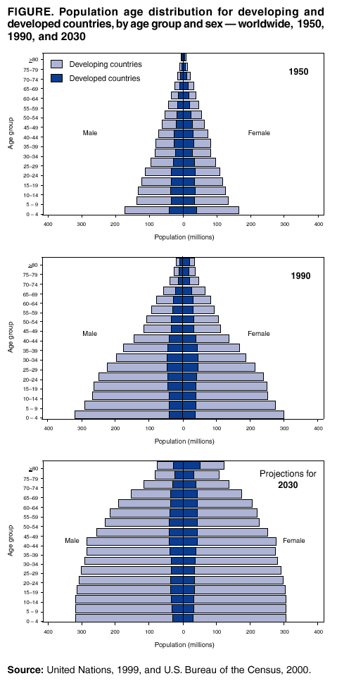

By the year 2060, the projected number of people in the United States who are aged more than 65 years is expected to double. The current population with more than 65 years is 46 million and the population is supposed to increase to 98 million people in 2060. The proportion of the population that is aged above 65 years is expected to increase from the current 15% to 24% in the future. According to statics, the population of the people in the country is currently more ethnically and racially diverse. The projection for the population that will change from 2014 to 2060nis expected to be a larger share of the older population is expected to be non-Hispanics will drop by 24% from the current 78.3%. The current change in the ethnic and racial composition of the population that is aged below 18 years relative to 65 years is expected to create the diversity gap between the two generations.
The other notable observation is the fact that the older population is currently working for longer hours. According to statistics, the number of people who were aged 65 years and above and were working by 2014 included 23% of men and 15% of women. The percentages are expected to increase by 2022 to be 27% of the people, aged above 65 years will be working while 20% of the women aged above the age will also be working.
Top concerns for the senior citizens
- Obesity rates-Obesity is a major challenge for a huge population in the United States. The senior citizens are also being affected by the issue. According to statistics, more than 40% of the people aged between 65 and 74 years in the country are affected by the obesity issue.
- Economic disparities- There have being an increase in the economic disparity among people in the world. By the year 2014, 18% of the people who were aged above 65 years were living in poverty. 8% of Hispanics and 19% of African Americans aged above 65 years also lived in poverty.
- Increased divorce rates- The divorce rates in the countries have increased over the years. The rate of divorces has increased from 3% in 1980 to 13% in 2015 amongst the women. For the men, the divorce rate increased from 4% in 1980 to 11% in 2015.
- Alzheimer’s disease- There has being an increase in the demand for elder care because of the increase in the number of people living with Alzheimer disease.
- Social security- The increase in the population of the elderly people will also lead to an increase in the expenditure on Medicare and social security by 12% by the year 2050.
- Nursing home care- The increase in the number of the elderly in the country will require an increase in the budget on home care expenses. The expenditure for the country is expected to be at 2.3million in 2030 and increase form the 1.3 million in 2010.
- Reduction in current gaps- The policy makers in the country can work towards improving the gaps that exist in earnings, employment and education amongst the yond people. That will work towards ensuring that the elderly people in the future are well catered for and they have means to survive.

Works cited
B. Adrian. Overview of the mobile payments market 2002-2013. Gartner, 2012.
Eric Raymond, The cathedral and the bazaar. Knowledge, Technogy, and Policy. 2009.
Yahoo Finance. Sealed Air Corporation. Fiancial statemnst. Retrived on 19th September 2018 from https://finance.yahoo.com/quote/SEE/
Yahoo Finance. Walmart Inc.. Fiancial statemnst. Retrived on 19th September 2018 from https://finance.yahoo.com/quote/WMT/financials/
Yahoo Finance. Amazon Inc.. Fiancial statemnst. Retrived on 19th September 2018 from https://finance.yahoo.com/quote/AMZN/financials/
Yahoo Finance. . Fiancial statemnst. Retrived on 19th September 2018 from https://finance.yahoo.com/quote/bll/financials?ltr=1

